Summary for pre-read

WBR - Summary (for Pre-Read)
1. COMMERCIAL
• Sales Forecast: 90% forecast with 56.5M vs target of 62.6M
2. PRIMARY (New Projects, Media, Dev)
• New Projects Gross Revenue: Revenue met target $171.4K ( vs Target of $144.6K, +18.5%), sold leads back in green. Sessions remain under target (miss overcompensated by better conversion and price). Feb forecast: Gross Revenue >100%, Sold Leads 95%, Sessions 90%.
• Media & Developers: Forecasting 100% sales achievement in February.
3. DEMAND (Paid / Unpaid)
• Web Paid: Sessions (575k, +11% vs target), Leads at 57.8k (-13% vs target) and CR at 10.1% (-2.8pp vs Target)
• App Funnel: Sessions (639k, -3.7% vs target), Leads at 140k (+2.7% vs target) and CR at 21.9% (+1.4pp vs Target)
• SEO Share of Voice: Total 41.6% (-0.3pp WoW, -0.5pp MoM). Buy 65.3% (- 4.3pp WoW); Rent 47.8% (-1.7pp WoW, - 3.2pp MoM). Generic 29.0% (+1.4pp WoW, +2.1pp MoM).
4. B2C APP ENGAGEMENT
• App Engagement & Installs: Installs at 24.3k (+61% vs target) and App MAU at 456k (+5.7% vs target)
• App Rating: Android App rating dropped from 4.3 to 4.2 as Google removed legitimate 5-star ratings. ETA to recover: beg March
• Login Ratio: 26.4% (-2.2 pp vs target), however week on week improvement of 0.7pp
5. B2C TECH METRICS
• App Stability: iOS Appdex score is at 91.7% vs 95% target. Luciq’s SDK issue spotted in the previous WBR. Recovery already in place. Android Appdex score in at 96% (+1pp vs Target)
• Web Stability: Mobile INP Good Rate is at 69.6% vs 72% target, and expected to continue recovery over the next 3-5 weeks
6. B2B PRODUCT
• Incident Volume: P0: 3 (vs target 1.3) P1: 8 (vs target 17). The weekly limit is crossed. However, within monthly target range
• Agent Engagement: App active agents 10,676 (+0.4% vs Target) and WAU 3,496 (+7.6% vs Target)
7. LISTING QUALITY
• Compliance: 91.9% vs target of 87%

DLD Market Growth

Property Finder
Weekly Business Review

Market (Dubai)
- The overall market continues to grow at 35% by value, largely driven by Primary growing at 43% YoY and Secondary at 24% YoY

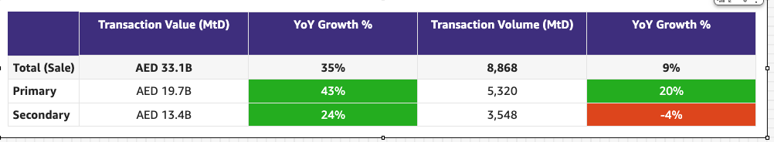

Commercial

Commercial
Category | DRI | Which metric is red and why | Actions planned | ETA for target achievement
Sales forecast % | Vladimir Malugin | The commercial team is pushing very hard to maximise February in the last week. Forecast at 89% with upside to 91%. (Forecast w Hamptons at 95% with upside 97%)  - Aqua landed at 55% increase vs a maintain opening  - Hamptons: Achievement moved to March while target stays in February due to 1 month contract extension.  - Paragon Properties: +8% increase on current base (vs 26% growth target) after super-challaning negotiations. Performing well as an Edge client, but unwilling to stretch further given perceived benefit realization  - Mega Homes FZC: Major win in negotiations are to maintain/grow vs 116% target, after indication of downgrade. Historically conservative decision-making, with recent stronger conversion on Bayut.  - DXB NB at 72% with slower DLD registrations - up from 65% earlier in the month | Continued focus on increasing sales through the following actions:  - Operational Excellence: 60% improvement over the last 3 weeks. Weekly Salesforce hygiene updates to ensure clearly identifiable, actionable records; strong focus on customer centricity (100% OK rate + structured client feedback) and proactive pipeline & sales risk tracking.  - Account Plans: Structured plans in place for key accounts to drive focused growth and retention - 90% competed in Diamond  - Renewal Narratives: Strong partnership with Commercial Analytics to build clear, data-backed renewal stories for Diamond and Ruby accounts - Aqua case in point
Exclusive Listings | Michelle Brackley | - Rebaselining decision has been taken: Non-compliant listings and duplicate listings will be removed from baseline. Live rebaselined data will be available by 6th March | Updates from last weekly meeting:  1. New Business SPIFF for Exclusive Listings  Status: Done  Owner: Commercial Strategy  2. Non-Compliant Listings  • Baseline recalibration  Owner: BA team  ETA: 6th March  • WA reminder to agents  Owners: Pascal  Action: Evaluate sending WhatsApp notifications from Braze to admins and agents, in collaboration with Alexandru from Engineering  ETA: Update by 26th Feb  3. Automatic Import of BY Exclusive Listings on Expert  Owner: Hugs  ETA: 16th March  Dependency on DE team for daily scraping (vendor to be closed this week)  4. CPL Discount on BY Exclusive Listings  Owner: Anirudh  ETA: 9th April  5. Milestone-Driven Benefits (incl. SuperAgent Points – “First to PF”)  Owner: Hugs, Sajjad  Action 1: Hugs and Sajjad to design mock-ups by this week  Action 2: Meetings next week with top 10 clients for feedback on proposal  Dependency on DE team for daily scraping  6. Compass Data Narrative  Owner: BA team  Action 1: March 3rd for getting the listings in Sales Compass  Action 2: March end for getting the narrative on Sales Compass  7. Community Performance Marketing  Action 1: Exclusive listings will be incorporated into the ranking methodology for "Top Communities"  Owner 1: BA Team  ETA 1: TBD  Action 2: Evaluate if campaigns can be conducted for communities with high Bayut exclusive listings and outside top 25 PF communities  Owner 2: Soumar  ETA 2: TBD

Weekly Metrics
 |  | Weekly |  |  |  | MTD
Category | Metric | Week  (Actual) | Week (Target) | WoW | vs 2 weeks prior | MtD  (Forecast) | Month (Target) | vs MtD  prev month (MoM) | vs MtD  prev year (YoY) | vs competition | DRI | Dash
Sales  (MtD) - UAE | Sales Forecast %  (Month-end) | Monthly -> |  |  |  | 56.5 Mn  (90%) | 62.6 Mn | Not Applicable | Not Applicable | Not Applicable | Vladimir Malugin | Link

CLEL to not be discussed in Q1, till baseline is defined and Product actions are in place

Category | Metric | Week  (Actual) | Week (Target) | WoW | vs 2 weeks prior | MtD  (Actual) | Month  (Target) | vs MtD  prev month (MoM) | vs MtD  prev year (YoY) | vs competition | DRI | Dash
Net exclusive listings | Rent | 2.9K | NA | -0.8K  3.7K | 0K  2.9K | NA | NA | NA | NA | Not Applicable | Prateek Goel
 | Sale | 12.3K | NA | -0.1K  12.4K | -0.3K  12.6K | NA | NA | NA | NA | Not Applicable | Prateek Goel
Supply | Net Exclusive Listings | 15.1K | NA | -0.9K  16K | -0.4K  15.5K | NA |  | NA | NA | Not Applicable | Prateek Goel
 | Total Listings | 373.4K | NA | +3.3K  370.1K | +4.7K  368.7K | NA | NA | NA | NA
 | Dubai | 218.4K | NA | +2.7K  215.7K | +4.1K  214.3K | NA | NA | NA | NA
 | Abu Dhabi | 16.7K | NA | -0.2K  16.9K | +0.2K  16.5K | NA | NA | NA | NA
 | Northern Emirates (incl Al Ain) | 138.3K | NA | +0.8K  137.5K | +0.4K  137.9K | NA | NA | NA | NA

Primary (NP, Media, Dev)

Primary (New Projects, Media Sales)
Category | DRI | Which metric is red and why | Actions planned | ETA for target achievement
New Projects | Enguerran Milhiet | - Revenue target still green, sold leads back in green.  - Sessions remain in red however the miss is overcompensated by better conversion and price (see revenue).  - Main root cause for sessions to be red: delay in starting SEO initiatives and performance marketing campaigns.  - No help needed, actions already taken. | - Accelerated SEO initiatives (Community reviews, internal links , Googlebot).  - Optimise performance marketing campaigns (already happening). | Expectation for February:  - Gross revenue: >100%  - Sold leads: 95%  - Sessions: 90%
Media & Developers | Sami Awada | - Continue to forecast 100% sales achievement in February. | - N/A | - On target for February.

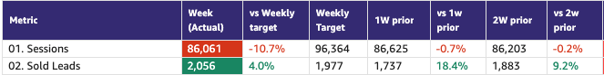
Gross Revenue(USD) excluding media | $171.4k | +18.5% | $144.6k | $148.1k | +15.7% | $163.2k | +5.0%

Demand (Paid/Unpaid)

Demand
Category | DRI | Which metric is red and why | Actions planned | ETA for target achievement
Paid | Ahmed Osman | - Web Paid Listing Leads: Below target as we’re seeing a massive increase in non-listing leads from the end of Jan till Mid Feb. | - BA to analyze the reasons for the surge in non-listing leads coming from paid search, mainly.  - Hypothesis #1: Data tracking issues affecting the classification of leads. [JIRA Ticket]  - Hypothesis #2: A genuine increase in agent leads from paid web traffic sources, given recent product changes [SuperAgent Carousels in SERPs]. | - March 2026.
Unpaid - SEO | Mahmoud Nessim | - SoV is flat ( -0.3 ) just normal fluctuation on the metric, due to an on-going Google update, this week numbers are getting far better than previous months hitting above SoV 44% and growing | We’ve an active group about bridging the gap in the rental SoS, as it laggs everything behind actions are:  - Bridging the gap between us and the competition for key communities ( We’ve done the analysis with BA for a correlation of ~5 P.P Rental SoS increase if we bridged the gap, just the gap )  - Scaling the efforts towards other initiatives like UGC, Footer content & Data, changes on the pagination, CWVs, content engine, internal linking | - UGC will be live on SERPs, PLPs by 1st week of March  - Footer content revamp is projected to go live by first week of March  - Utilizing the campaign engine to acquire the missing listings. ( ETA TBD )
Unpaid - Overall | Soumar Aoun | - App is green  - Web direct is still being fixed under data governance. Data to be ready by next week. | Past 2 Weeks — What Shipped :Strong velocity across Discovery + CRM, with meaningful structural changes now live.  - CRM Re-engagement Expansion (App + Web) — 100% Live  → 3x increase in opens  → +100% uplift in CRM-driven sessions (test period)  - 2D Floor Plans (App + Web) — 🧪 Live @80%  → 20K floor plans across 77 communities  → Early conversion positive  - My Activity Hub (App) — 🧪 Scaling to 50%  → Estimated +2% repeat sessions (users with 1 lead)  → +1% login rate uplift (early signal)  - Onboarding Improvements (App) — 🧪 Live @50%  → Readout pending (A/A validation in progress)  - Personalized Recommendations (Web – eLPL) — 🧪 Live @50%  → Early +4% slot CVR trend (under new experimentation framework)  ⚠️ Note: App experimentation splitting issue identified. B2C + BA running A/A test to fix signal integrity before further scaling.  Objective: Increase dwell time, repeat sessions, and CRM-driven recovery.  📌 Full initiative-by-initiative breakdown (design links + owners + readouts) available in the detailed Shipping Update doc. | Next 2 Weeks — What’s Coming  Focus: Login acceleration + PLP/SERP conversion + deeper engagement loops  🔐 Login Acceleration  - Mobile + WhatsApp validation (launching 4/3)  → Expected Q1 impact: +5% login uplift potential  → Long-term: path to 50% login rate if validated  📈 PLP / SERP Conversion Uplift  - Desktop PLP Revamp (23/2)  - App Navigation + Section Hierarchy (25/2)  - SERP Revamp (27/2)  - Floor Plan Icons on SERP (2/3)  - Video Quick Access on PLP (2/3)  - CTAs on Recommended Properties (6/3)  Objective: Structural seeker-first hierarchy + stronger CTA visibility → conversion uplift.  🔁 Engagement Depth  - App Home Page rebuild  - New Content Surfaces (App)  - Travel Time Push Notifications  Create Alerts Revamp  - CRM Web Email Revamp

Competition:
1. SoV - SEO

Metric | Week (Actual) | 1W prior | vs 1W prior | 2W prior | vs 2W prior | MtD (Actual) | MtD PM | vs MtD PM
Total | 41.6% | 41.9% | -0.3 | 41.2% | +0.4 | 41.5% | 42.0% | -0.5
Buy | 65.3% | 69.6% | -4.3 | 66.1% | -0.8 | 66.8% | 66.6% | +0.2
Rent | 47.8% | 49.5% | -1.7 | 48.2% | -0.4 | 48.5% | 51.6% | -3.2
Generic | 29.0% | 27.6% | +1.4 | 28.3% | +0.7 | 28.4% | 28.0% | +2.1

2. Demand Funnel
(Direct and SEO Data are currently being fixed under Data Governance Workstream)

Web - Paid

App - Total

Exposure LPL
(EXCLUDES DIRECT)

Key facts and numbers:
- A key reason that sales exposure targets are in red is that the market growth assumptions used to set targets are different to what is happening in reality.
  - Secondary Sales: Expected volume market growth of 13% vs actual MTD volume growth of -4.3%
  - Primary Sales: Expected volume market growth flat vs actual MTD volume growth of +20%
- Secondary sales drives the majority of the sales leads (~85%) on our platform. Hence, secondary market volume de-growth is leading to a big impact on overall leads and hence, exposure leads and hence, exposure LPL.
- On Primary sales, MTD leads are lower than last year while market volume growth is higher than expected. Hence, there is potential to improve here.
Situation:
- RoAS: Is not working as well for the UAE as other countries. Facebook marketing works best for RoAS and UAE has lower contribution from that channel vs previous RoAS countries.
- Secondary Leads:
  - Marketing is spending more on rental leads, as they are cheaper vs sales leads. This is to ensure we meet total lead targets within the allocated budget.
  - Clients generally are asking for more sale leads in a market that is more sales driven currently.
  - As per Ahmed, the only lever marketing currently has to drive more leads to exposure sales, is to spend more on sales leads.
  - However, this could negatively impact cheaper rental leads and total leads, given our total marketing budget is fixed
- Primary Leads:
  - Key area where we are underperforming.
  - Marketing does not have any control to acquire more primary leads.
  - Marketing focuses to push acquired primary leads to New Projects (where leads have grown 32% YoY, which is higher than primary market volume growth)
- CRM:
  - Tracking of CRM emails was identified and fixed for the web on 10th Feb.
  - App investigation being concluded by Wael from Martech.
  - Some initiatives planned for mid-March and mid-April that could impact exposure LPL. Focus is on the new framework associated use cases and new comms.
Next Steps: To meet sales LPL targets, we need more leads on sales and more exposure leads on sales
- Shift marketing spend towards sales to capture more sales demand, while maintaining the marketing guardrails around CPL etc.: Ahmed (Ongoing)
- Identify ways to drive higher primary leads: Ahmed (TBD)
- Timeline to investigate app and fix CRM tracking: Wael
- List of planned CRM initiatives that will impact exposure LPL to be shared: Emmanuel (before next WBR)
- Timeline to begin these CRM initiatives to drive more leads to exposure: Emmanuel (mid-March and mid-Apr)
- Continue to gather client feedback and raise a red flag, if there is increased noise from clients on exposure LPL: Paresh
Support required:
- Clarity required: Given big differences in target setting assumptions and actual market growth, should we continue to measure against current targets? One reason every week for being in red will continue to be this. Or should we update targets based on actual market growth?
- Ideas on how to further drive increase exposure leads to both rent and sale and on primary sales

Leads and Listings distribution

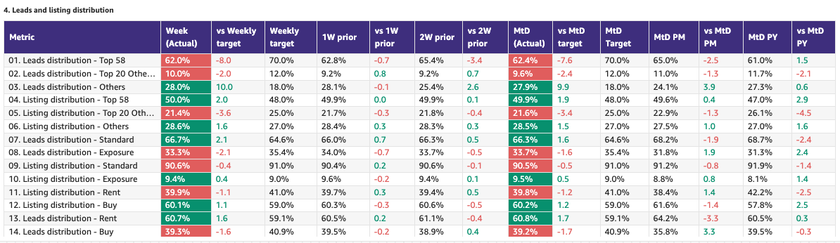

Rent vs Buy Split

Monthly Metrics

B2C NPS
Category | Metric | MtD  (Actual) | Month (Target) | vs MtD  prev month (MoM) | vs MtD  prev year (YoY) | vs competition | DRI | Dash
B2C NPS | B2C NPS |  | Not Available |  |  | Not Available | Alson Dsouza

PR Metric
Category | Metric | MtD  (Actual) | Month (Target) | vs MtD  prev month (MoM) | vs MtD  prev year (YoY) | vs competition | DRI | Dash
PR | PR Sov | 97.9% | 50-55% |  |  | 0% Bayut  2.1% Dubizzle | Natalie Faulkner | PR team

Leads click to delivered:
Category | Metric | MtD  (Actual) | Month (Target) | vs MtD  prev month (MoM) | vs MtD  prev year (YoY) | Δ vs Competition | DRI | Dash
Leads Funnel | Total Leads Delivered (WA) |  |  |  |  | Not Available | Olivia Watters | Link
 | % Clicks to Delivered (WA) |  |  |  |  | Not Available | Olivia Watters | Link
 | Error Leads (WA) |  |  |  |  | Not Available | Olivia Watters | Link

- Competition
  - Share of Session (Overall, Web Channels, App Channels)
  - SoV - Paid click share

- Demand Funnel
  - Sessions (by channels)
  - Leads (by channels)
  - CR (by channels)
  - Click to Delivered

- Exposure LPL
  - Overall / Rent / Sale
  - Top Communities
  - Web/App
  - Exposure Leads as % of Total Leads (Overall / rent / sale)
  - Exposure Listings (Overall / rent / sale)

- Engagement Metric (Time on site)
- B2C NPS
- PR SoV - we are way ahead of the competition in terms of SoV - thanks to a number of press stories, including mention in Stake’s series B financing announcement.
- Leads split by Rent vs Buy

Data Governance

DATA GOVERNANCE
Data Issue | Latest update | Resolution update (ETA) | DRI
Spam Issues | - Remove spam activity from all reporting tables across both GA4 and Snowplow leveraging third party tool (Cheq)  - Pending  - Validation that Snowplow and GA4 data are aligned - Wael Abdella  - Go-live plan (i.e. 80+ tables to be updated cannot be done in one go) - Aamir Shaiq  - Define tech solution to block “bad” spam activity so it can be prioritized during Q2 roadmap planning  - Assess the need and feasibility of leveraging cheq spam classification into delivered leads spam detection model | - Tentative 26th February  - 6th March  - Tentative: 27th February | - Mahesh Maheswaran  - Amory Kelie  - Sruthi Poduval
SEO (Sessions vs clicks) | - Agreed on starting reporting SEO traffic as-is once spam activity is removed | - Tentative 26th February | Wael Abdella  Volkan Oktem
CRM Attribution Reporting | - Understand the route cause of the discrepancy between braze clicks and Kochava session - stacked | - Tentative: 26th Feb | Wael Abdella
Kochava Integration Update | - Upgrade integration between Kochava and PF Expert | - 6th March | Khaled Thabit

B2C App Engagement

B2C App
Category | DRI | Which metric is red and why | Actions planned | ETA for target achievement
App engagement & installs | Ahmed Osman | - Green. On track to achieve an ATH MAUs. | - ASO: A complete refresh of app screenshots is planned by Early March to reflect new app USPs and a new creative theme.  - Paid UA: Planned activities for the remainder of Q1, focused on more diversified messaging (HV, My Activities, New Simplified UI). | - N/A
App ratings | Soumar Aoun | - App Rating (Google Play) 🔴 Red (4.5 → 4.2):  (1) ~300 five-star ratings removed due to Google spam detection logic triggered by high velocity of reviews.  (2) Additional increase in 1-star ratings under investigation.  - Logged-in User Ratio (Feb MTD) 🟡 Slight MTD Dip (Not Structural)  Month-to-date variance; weekly trend stable/growing. No platform-specific decline observed. | - App Rating  - Aligned with Google; confirmed spam filtering logic. (4.5 to 4.3)  - Reduced in-app review triggers aggressiveness (1-day → 3-day).  - Deep dive on 1-star spike (source, platform, flow correlation). (4.3 to 4.2)  - Log in  - Continued monitoring at weekly level.  - No structural intervention required.  - Validate normalization at month close.  Login Launching next 2 weeks  - Mobile + WhatsApp validation (launching 4/3)  → Expected Q1 impact: +5% login uplift potential  → Long-term: path to 50% login rate if validated | - App rating  - initial deep dive findings by 24 Feb.  - Stabilization expected within 4–6 weeks post strategy adjustment.  - Log in : On track to reach 28% by the end of Feb.

Weekly Metrics -

- App Installs
- App MAU
- DAU/MAU
- Sessions / DAU
- Login Ratio
- Avg Session Duration
- Playstore rating (Android)
- Playstore rating (iOS)\

B2C Tech Metrics

B2C App
Category | DRI | Which metric is red and why | Actions planned | ETA for target achievement
App stability & performance | Taran Kambow
Web Stability & Performance | Amory Kelie | - The 1pp INP drop is concentrated on Search Landing Pages (~22% of interaction volume), our primary SEO and Paid entry surface.  - That surface regressed ~7% WoW, explaining the overall movement.  - Early signal suggests recent JS / tag / experiment injection increased main-thread pressure on that template.  - The degradation is localized — not systemic across templates. | - Regression isolated to Search Landing Pages (SEO + Paid entry surface)  - Auditing and rolling back non-critical JS / experiment injections where needed  - Enforcing performance budget on acquisition templates  - Daily monitoring of INP on entry surfaces  - INP is Interaction to next paint, when isolating the pages component by component we’ve found out the AI search is the one causing the delay, aligned with the search team for actions. | - Stabilise to 72% in 3–5 weeks; reach 75% by end of Q2.  - Search team to implement the AI search INP fix by next sprint.

 |  | Weekly |  |  |  | MTD
Category | Metric | Week  (Actual) | Week (Target) | WoW | vs 2 weeks prior | MtD  (Forecast) | Month (Target) | vs MtD  prev month (MoM) | vs MtD  prev year (YoY) | vs competition | DRI | Dash
Tech stability & Performance | Mobile INP Good rate (%) | 69.6% | 72% | -1pp | -2pp | NA | NA | NA | NA | NA | Amory Kelie

- Appdex: Android
- Appdex score: iOS
- CWV

B2B Product

B2B
Category | DRI | Which metric is red and why | Actions planned | ETA for target achievement
CSAT (P0s) | Luis Cappa | We are Green to meet our Monthly Target of max 6 P0s and 73 P1s per month with an accumulated MtD of 3 P0s and 34 P0s. The Incident Volume, combining both P0s and P1s, points us to the month with the lowest operational load over the last 2 years.  However, we received 3 P0s last week, Red for the Weekly Target of 1.3 P0s/week target but still under the Monthly Mark:  - Authentication defect (Core Platform).  - Invalid Permit defect (Data Engineering).  - Listing Management View (Property/Catalog Experience). | No actions planned - Business as Usual.  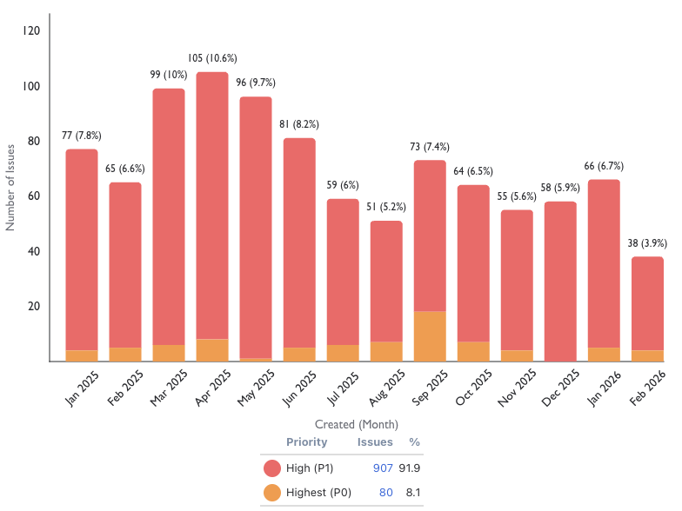
Agent Experience | Sajjad Ahmad | Metric in green.

Weekly Metrics
 |  | Weekly |  |  |  | MTD
Category | Metric | Week  (Actual) | Week (Target) | WoW | vs 2 weeks prior | MtD  (Actual) | Month (Target) | vs MtD  prev month (MoM) | vs MtD  prev year (YoY) | vs competition | DRI | Dash
CSAT | Incident Volume | P0: 3  P1: 8 | P0: 1.3  P1: 17 | P0: +3 (from 0 baseline)  P1: -20% (8) | P0: (0)  P1: -24% (13) | P0: 3  P1: 34 | P0: 6  P1: 73 | P0: -100% (3)  P1: +0 (24) | P0: -100% (2)  P1: -25% (32) | Not Available | Luis Cappa | Link  (JIRA)

Agent Engagement & Experience | App active agents | 10676 | +0.4%  10624 | +2.3%  10440 | +4.8%  10190 |  |  |  | Not Available | Not Available | Sajjad Ahmad | TBA
 | Active users per week (WAU) | 3496 | +7.6%  3248 | +1.5%  3444 | +2.6%  3408 |  |  |  | Not Available | Not Available | Sajjad Ahmad | TBA
 | Agent NPS | NA | NA | NA | NA | Monthly Metric |  |  |  |  | Sajjad Ahmad | TBA

Listing Quality

Monetization
Category | DRI | Which metric is red and why | Actions planned | ETA for target achievement
Compliance | Saif Al-Amid | - Metric in green | - This week we will start fake listings clean up exercise as a quick win for the allsop and allsop meeting. | - Daily batches starting from Wednesday  - GTM includes:  - Targeted email  - In-App PF expert banner  - LAT notification email  - Alignment with sales to hand hold top clients  - Whatsapp version to be used by BC’s/CSP’s.  - `

Special Projects
Monthly Lookbacks

Converting at risk clients to Promoters Ivan Gregorc Status
- Expected achievement at the end of the quarter. Based on current progress, what’s the estimated achievement rate for the end of Q1 2025?
By end of Q1, we expect to convert 50%+ of Neutral/Detractor clients into Promoters and protect renewal risk across the Marketing-owned portfolio (21 clients).
Assuming delivery on Product-dependent items.
- Achievement (till date) : Indicate completed and pending tasks.
- Client sentiment baseline established and tracked weekly
- Identified top 6 elements to turn Neutral clients into promoters
- Active engagement in place for all Target clients
Pending:
- Product fixes impacting SuperAgent points and lead quality
- Clearer value narrative on Premium Listings
- Impediments : If applicable, what is delaying the progress?
- The majority of blockers are Product-dependent
- Some perception issues (Awards, Premium value) require time and repetition to shift
- Initiatives to address impediments: What actions will we take to address the above issues or improve results?
- 4 out of the 6 (Spam Leads, Split Deals, Agent Engagements, PF Awards, Draft Listings) major issues brought up are being addressed by end of Q1
- 1 out of the 6 (Cost of Premium Listings) will be partially addressed by end of march through bundles rollout
- 1 remaining issue, the top 1, (SuperAgent Point System disadvantage in lower price-point communities) is being addressed by End of Feb.
Link to deep dive document

Special Projects - Q1 OKRs
Keyper Soumar Aoun Status

Bundles Paresh Goyal Status
- 21 client meetings completed as part of the validation phase
- Overall strong positive response on bundles, especially relating to SP/SF, credit discounts and ranking boost
- Key ask raised around limiting bundles to only a select set of clients and not everyone, in order to drive competitive advantage

North Stars

 |  | Month
Category | Metric | MtD  (Actual) | Month  (Target) | vs MtD  prev month (MoM) | vs MtD  prev year (YoY) | DRI
Output metric | Share of Wallet | 52.5%  (Jan 2026) | NA | -0.2pp | NA | Vladimir Malugin
North Star Metric | Share of Sessions | 57.8%  (Jan 2026) | 52.6% | +6.6pp  51.3% | +2.6pp  55.3% | Soumar AounAhmed OsmanMahmoud Nessim
North Star Metric | Net Exclusive Listings | 15.1k | Target setting in progress | -3.2K  19.2K | NA | Michelle Brackley

Exposure LPL (EXCLUDES DIRECT - Both in targets and actuals)
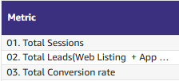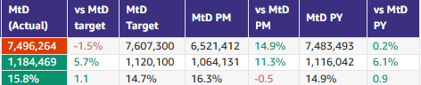
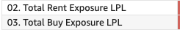

📋 Prev Saved Reports

Week | Date | Link
Week 6 | Feb 2 to Feb 8 | WBR - Week 6 (Saved) Metric Report
Week 5 | Jan 1 to Jan 31 | WBR - Jan Monthly Lookback (Saved Report) Metric Report
Week 4 | Jan 19 to Jan 25 | WBR - Week 4 (Saved) Metric Report
Week 3 | Jan 12 to Jan 18 | WBR - Week 3 (SAVED) Metric Report
Week 2 | Jan 5 to Jan 11 | WBR - Week 2 (SAVED) Metric Report
Year End.
W52 | Dec 1 to Dec 30 | WBR Metric Report - Dec Monthly Lookback (Saved Report)
W49 | Dec 1 to Dec 7 | WBR Metric Report - Week 49 (Saved Report)
W48 | Nov 1 to Nov 30 | WBR Metric Report - Week 48 - Nov Monthly Lookback (Saved Report)
W47 | Nov 17 to Nov 23 | WBR Metric Report - Week 47 (Saved Report)
W46 | Nov 10 to Nov 16 | WBR Metric Report - Week 46 (Saved Report)
W45 | Nov 3 to Nov 9 | WBR Metric Report - Week 45 (Saved Report)
W44 | NA | NA
W43 | Oct 1 to Oct 31 | WBR Metric Report - Week 43 - Oct Monthly Lookback (Saved Report))
W42 | Oct 15 to Oct 21 | WBR Metric Report - Week 42 (Saved Report)
W41 | Oct 8 to Oct 14 | WBR Metric Report - Week 41 (Saved Report)
W40 | Oct 1 to Oct 7 | WBR Metric Report - Week 40 (Saved Report)
W39 | Sep 1 to Sep 30 | WBR Metric Report - Week 39 (Saved Report)
W38 | Sep 17 to Sep 23 | WBR 2.0 Report - Week 38 (Saved Report)
W37 | Sep 10 to Sep 16 | WBR 2.0 Report - Week 37 (Saved Report)
W36 | Sep 3 to Sep 9 | WBR 2.0 Report - Week 36
W35 | Aug 1 to Aug 31 | Copy of WBR 2.0 Report - Week 35.docx
W34 | Aug 20 to Aug 26 | Copy of WBR 2.0 Report - Week 34.docx
W33 | Aug 13 to Aug 19 | WBR 2.0 Report - Week 33.docx
W32 | Aug 6 to Aug 12 | Copy of WBR 2.0 Report - Week 32.docx
W31 | Jul 30 to Aug 5 | WBR 2.0 Report - Week 31.docx

